TECHNICAL PROJECT REPORT

# Title of Invention / Project: Magic Stick Control Toy (Hand Gesture Control Mini-Quadcopter)

# Team Members / Inventors:

|  |  |  |  |  |  |
| --- | --- | --- | --- | --- | --- |
| **S. No.** | **Name** | **Department** | **Designation** | **Mobile** | **E-Mail** |
| 1. | Shradha Sagi | B.E. E.C.E. | Student | 7992214872 | shradha.kumari08092gmail.com |
| 2. | K. L. Srinivasa Raju | B.E. E.C.E. | Student | 9381246613 | klsrinivasaraju@gmail.com |
| 3. | Supriyo Dey | B.E. E.C.E. | Student | 7001294622 | deysupriyo786@gmail.com |
|  |  |  |  |  |  |
| 4. | Khushal Thakur | ECE | Mentor | 9646030764 | khushal.thakur@cumail.in |
| 5. | Anshul Sharma | ECE | Mentor | 9478697475 | anshulsharma.ece@cumail.in |
| 6. | Kiran Jot Singh | ECE | Mentor | 9463909689 | kiranjotsingh.ece@cumal.in |
| 7. | Divneet Singh Kapoor | ECE | Mentor | 9878422653 | divneet.ece@cumail.in |

Section – 1 (IPR Related)

# Brief Abstract:

* Problem your project is solving

By replacing the present R.F. by the R.F. of higher ranger then we can solve the problem of reaching those places were a man easily cannot reach. And with the installation of camera in it a person can totally depend on himself for the sake of videography and all.

* How are you solving that (solution)?

It is very easy to use even a child can a fly it. Its hand gesture control allows it to be used by even a inexperienced person.

* Additional modifications that can cater to improved solution.

Smaller size Ultrasonic can be installed to make the quadcopter protect itself at the time of collapsing it with something. And as mentioned before with installation of camera a person can be self-depended regarding videography and photography.

# Existing state-of-the-art and Drawbacks in existing state-of-the-art

|  |  |  |
| --- | --- | --- |
| **S. No.** | **Existing state of art** | **Drawbacks in existing state of art** |
| 1 | <https://www.electronicshub.org/hand-gesture-controlled-robot/> | It is unable to fly as well as size is little big as compare to the new model. |
| 2 | <https://youtu.be/Ymsep01SVjo> | It is very expensive as compare to the new model. |

# Novel/Additional modifications that you can propose to improve upon drawbacks

* Can add a small camera to make the quadcopter for using it videography and photography.
* Can add a feature to bring the quadcopter near you in case it get lost or it will prevent it going out of range.

# Advantages

* Cheaper than the existing model.
* Easy to use. Don’t need any external training to use it.

# Block Diagram

Section – 2 (Real Project)

# Materials

#### Components for Transmitter Section

* Arduino Nano
* 434MHz RF Transmitter
* HT-12E Encoder IC
* MPU6050 Accelerometer/Gyroscope Sensor
* 750KΩ Resistor
* Potentiometer

#### Components for Receiver Section

* L293D Motor Driver IC
* HT-12D Decoder IC
* 434 MHz RF Receiver
* 33KΩ Resistor
* 330Ω Resistor
* LED bulb
* 4 Coreless Motor
* Robot Chassis
* 6cm*0.7mm propeller

# Circuit Diagram

Receiver Circuit:

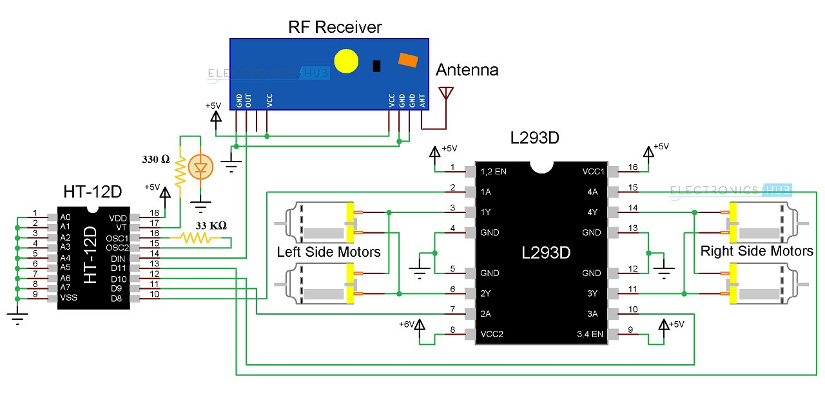

# Transmitter Circuit

# Steps of Circuit Completion

* Frist of all cut the PCB board in the size according to your need or otherwise you can look for the PCB of your need in the market
* Fix all the components roughly in the PCB board for just a reference.
* After fixing it solder the components. NOTE: - Soldering should be done on the opposite face of the plan side.
* Take two different point for connecting the wires from 5volt and ground terminal. NOTE: - Use thin connecting wire because it is easy to be solder. And try to keep the wire stuck to the board for preventing the mess over the board and as well as you will be able to connect everything without any confusion.
* Test the circuit once using a 9volt battery or DMM(digital multimeter).
* Upload the code in the ardrino nano using macro usb.

# Program Code

<https://github.com/SupriyoDey786/BEEELab_Project1/blob/master/Programs/gesture_control_quadcopter.ino>

* Problems faced while making the project.
* Initial problem was to fix the components and soldering it on the board as we were not that much experienced regarding soldering. We joined the connection very carefully and though we fail to make the receiver circuit correct at first attempt. We make the circuit thrice and every time we learned from the mistakes we had made in the tries before. Then we faced problem in uploading the program since the ardrino software was not showing the port selection option in our computer system. And moreover, the ardrino nano that are available in the market are not a good quality product they r often made in local market. The best ones are only made from Italy and they cost double than the local one. But after reinstalling the software than we were able to upload it. While writing the program you have to try and change the regulation of the motor speed as it depends on the order in which you placed the motor.